Teacher
- Same issue the top of the box get cut it need to be above the nav bar.
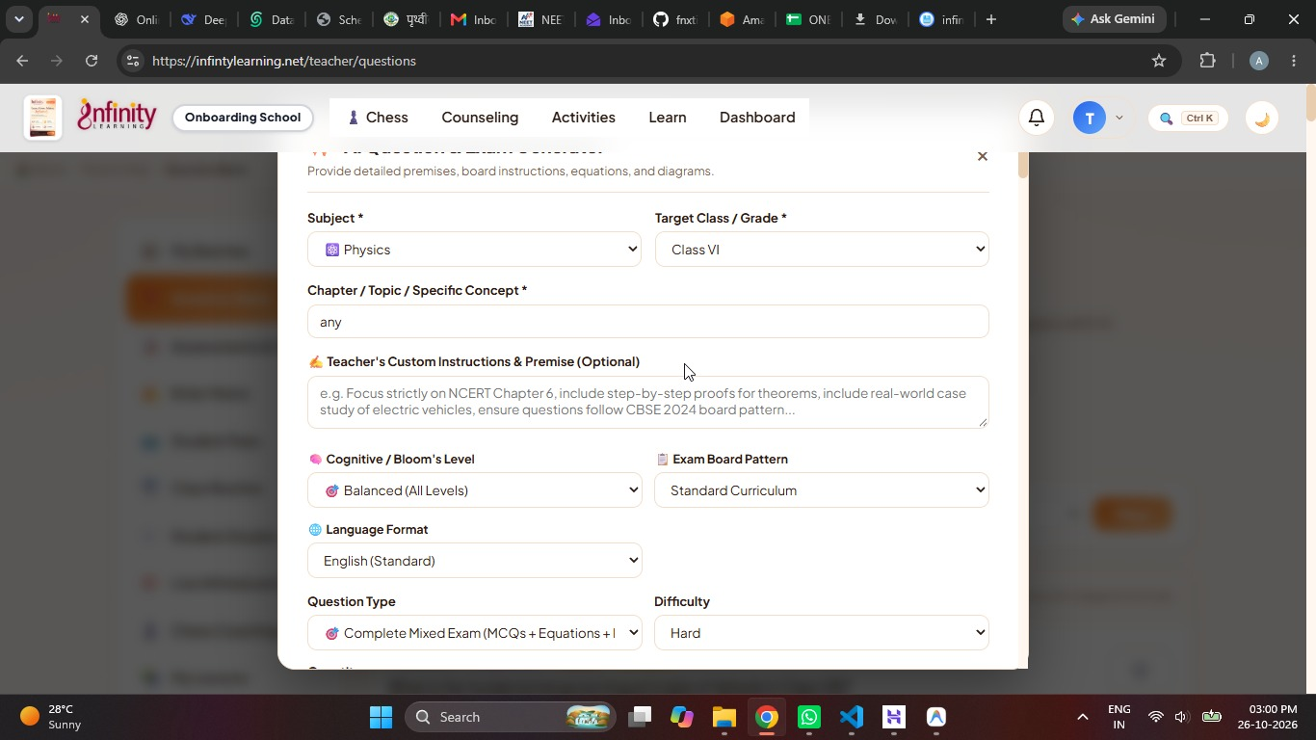
- when click on +create/..... we can create new assessment.
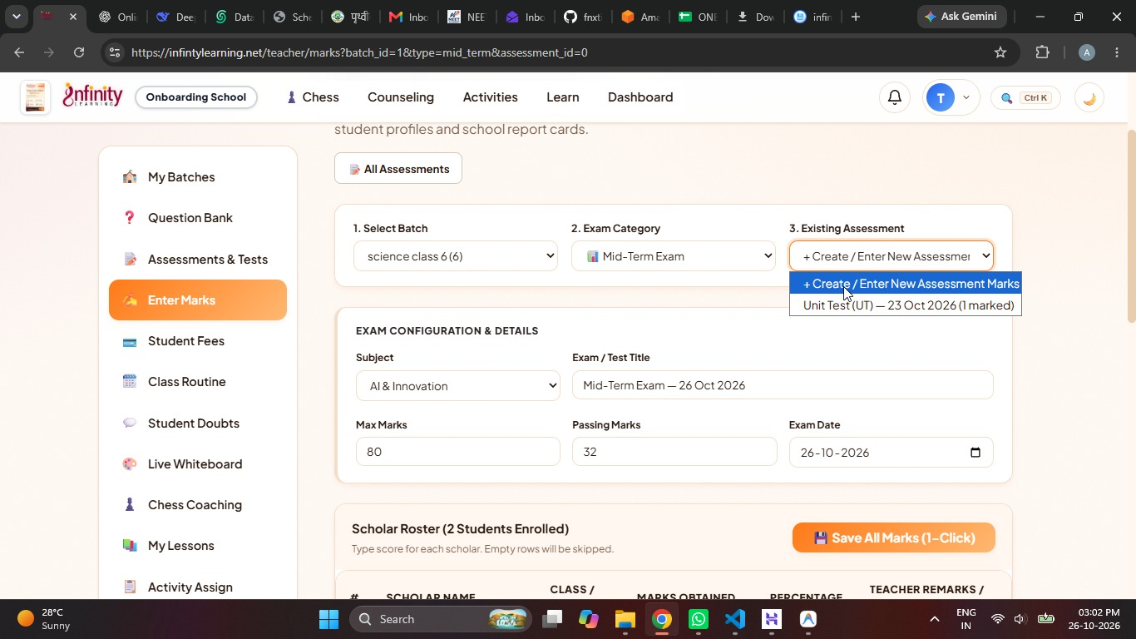
- In teacher profile we need to add a button to let teacher upload their signature, insted of head of academy it will be principle signature and it will populate autometaclly.
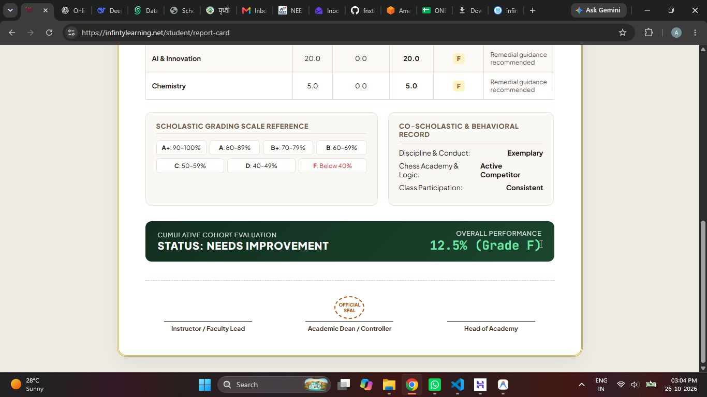

Student.
- This is student dashboard
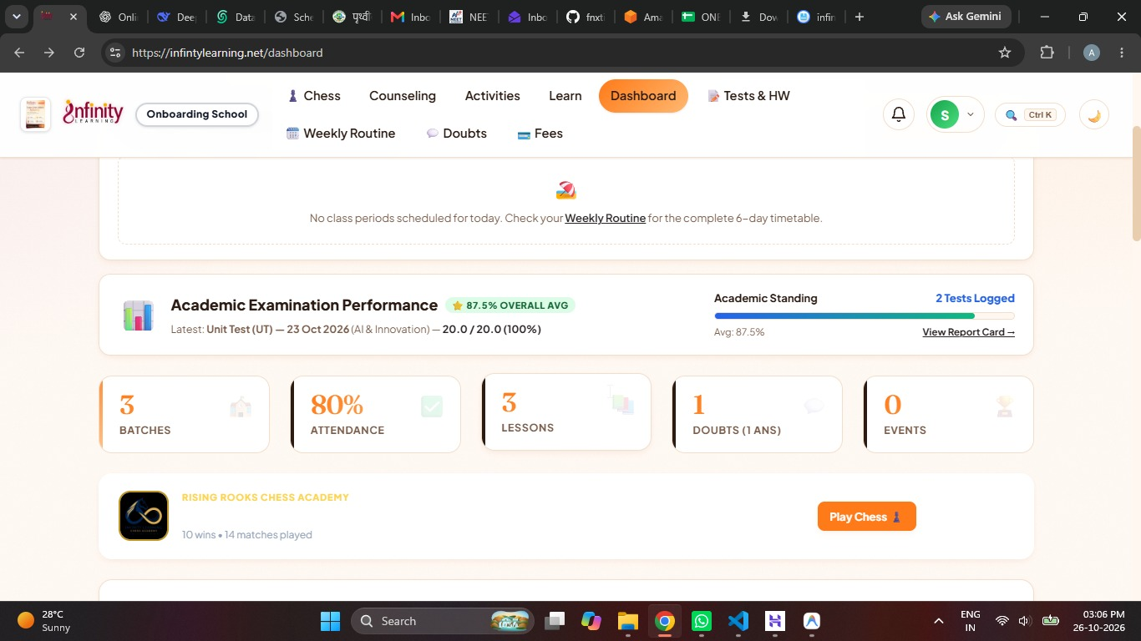

- But in student developemnt profile I cannot see any details.
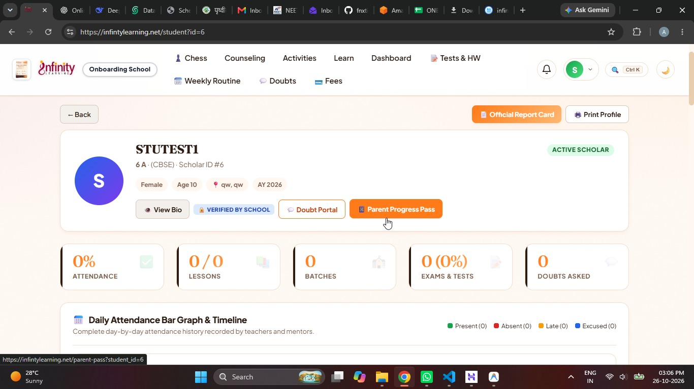
- In parent pass we do not need routine insterd this will be the gaph of marks trend and the attendance will be also in graph formate (bar).
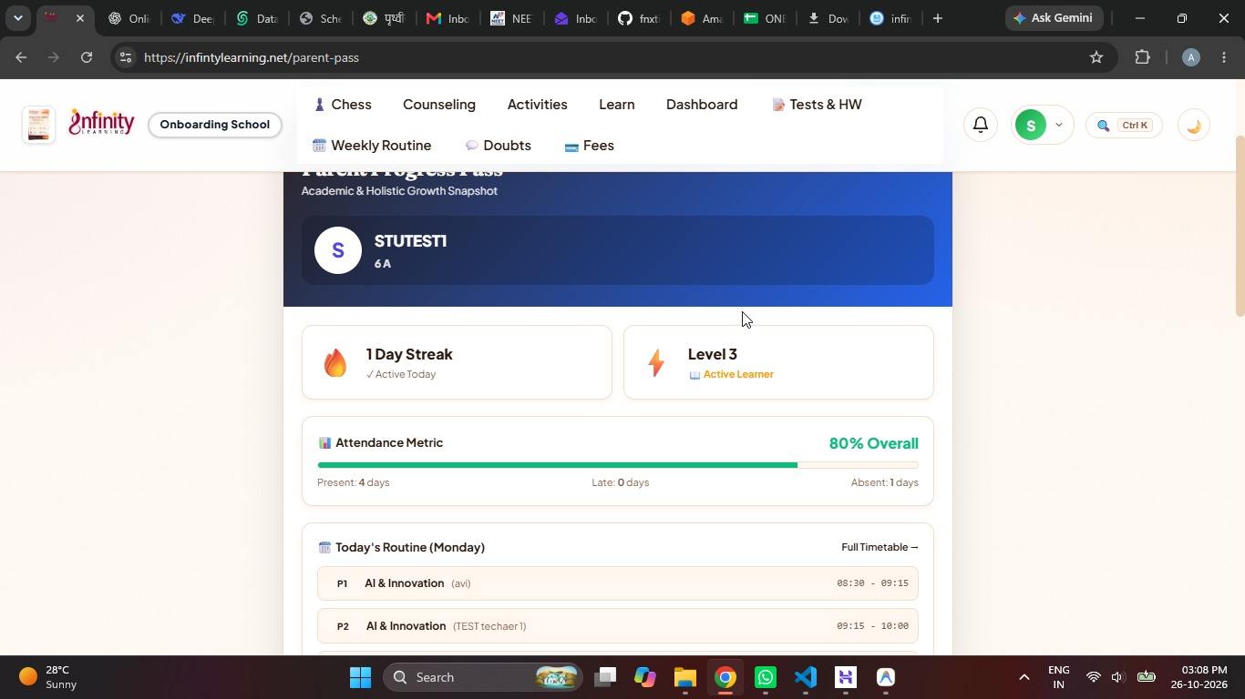
- From bar graph the word will be graph.

